AP Statistics Summer Homework

Why we like it –
Personalized, trusted content, feedback, this is a resource you can use all year when you miss class, content is confusing, you want more practice. Just make sure to use the AP Statistics

- On khanyacademy.org, you will create a login.

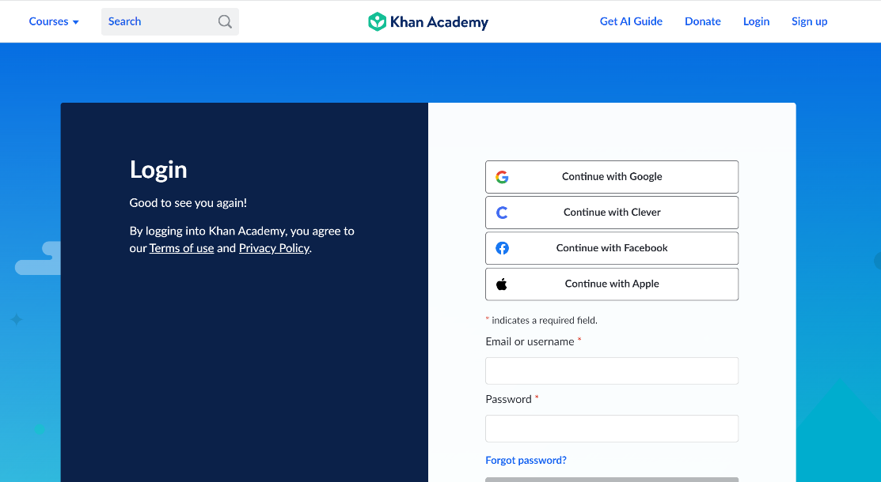

You should be able to sign in through Google using your WILLISTON e-mail address. If you already have an account with a personal e-mail, you can use that, too.
2. If you go to your name in the top right corner of the Website, you can click on Learner Home. You will see something like this:

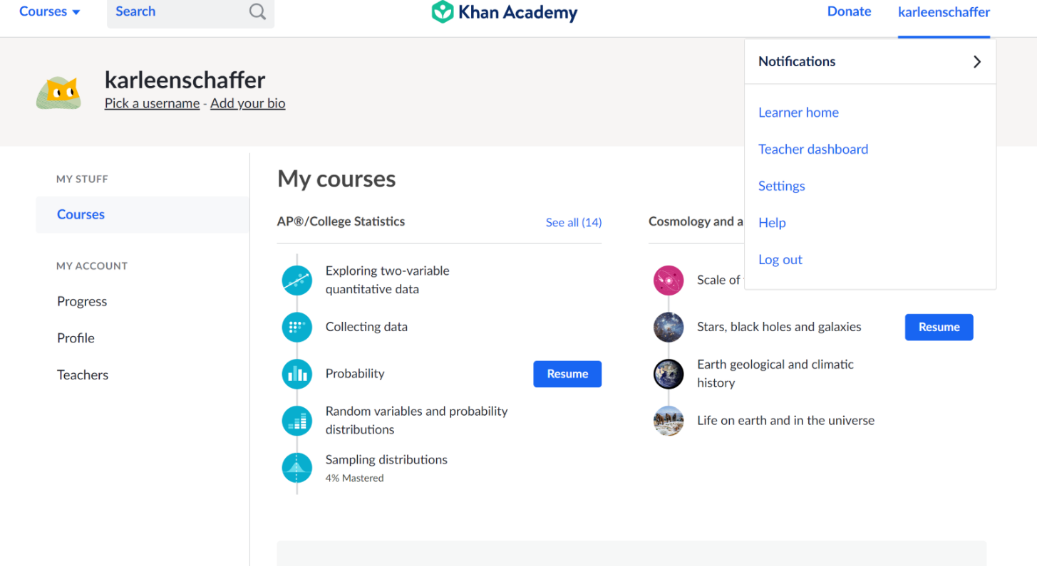

If you scroll down, you can add course. You should add the GETTING Ready for AP Statistics course (**** NOT the AP/College Statistics).

The following are the five modules you will cover in this work:
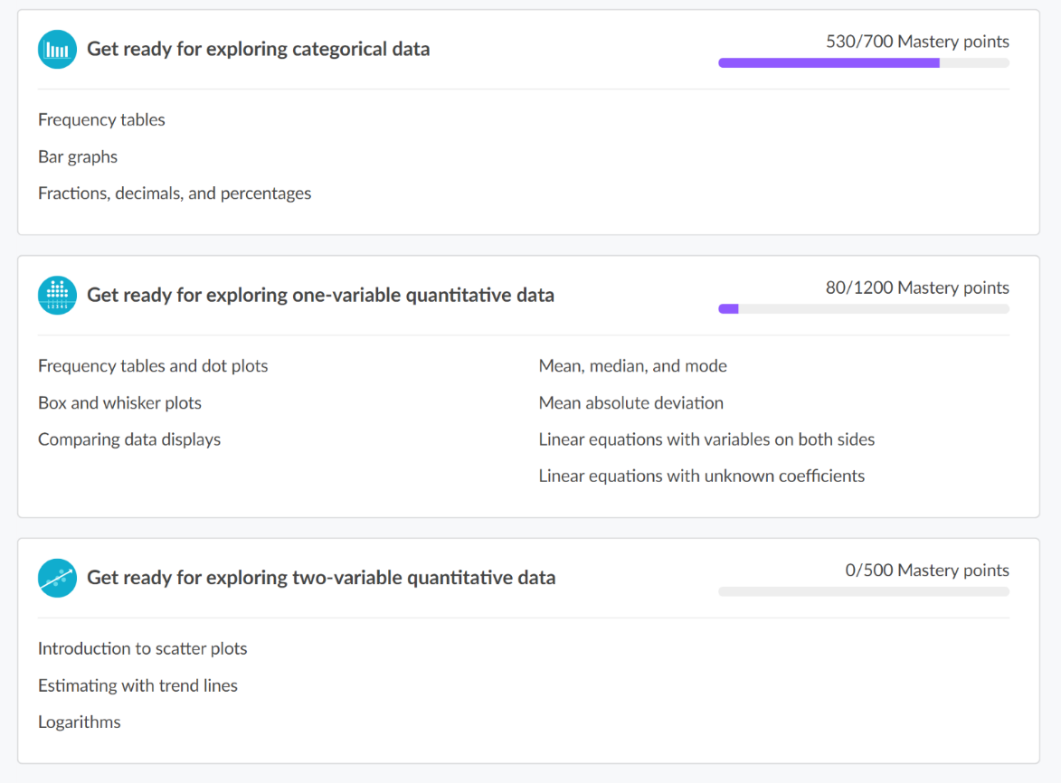
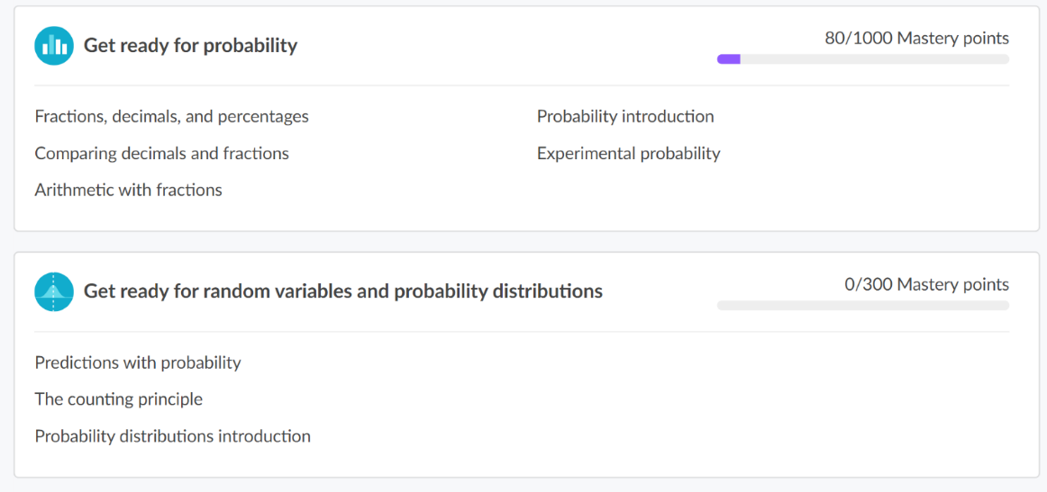

3. Skill Levels in the new Mastery System: Each skill is worth a total of 100 Mastery Points. As you practice skills and answer questions in quizzes, unit tests, and course challenges, your level for that skill will go up (or down, if you miss any questions in the course). Moving to Familiar will earn you 50 of the 100 points. Leveling up to Proficient will get you to 80 points. Become Mastered in a skill to collect the total 100 available Mastery Points.
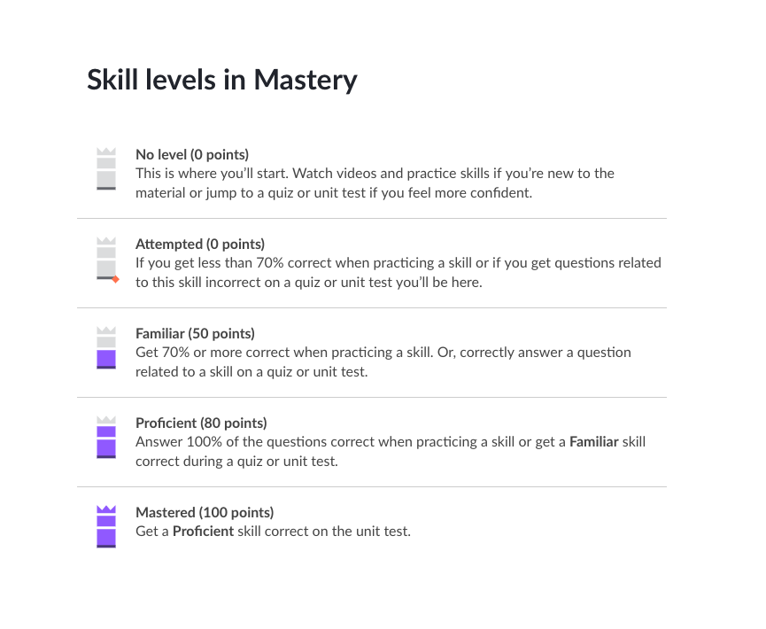

Mastery is not easily earned, and that’s intentional. But putting in the work to achieve it will prove you’ve earned (and learned!) it. We hope those of you in the Mastery system will enjoy leveling up your skills and reaching 100% Course and Unit Mastery.

- Other important notes:
- You must show 95% mastery for each of the 5 modules.
- Any problems or questions, please e-mail kschaffer@williston.com or mmallioux@williston.com
- Feel free to provide notes on these sections as you watch the videos. You can do them on OneNote if you can access it online or on loose-leaf and upload pictures when you receive your Surface.
- These will not be graded on accuracy but on completion.
- If there is a section you feel confident in before your start, try going right to the quizzes and tests to show your mastery.
- This will be graded as the weight of two homework assignments. Typically, there are 25-30 assignments throughout the first trimester.
- Make sure that you watch the video completely through. If you skip through it, it will not say that you’ve completed it at the end.

If you’d like a head start on material for the year, you can look at the first few chapters on the AP/College Statistics course. The topics are seen below.

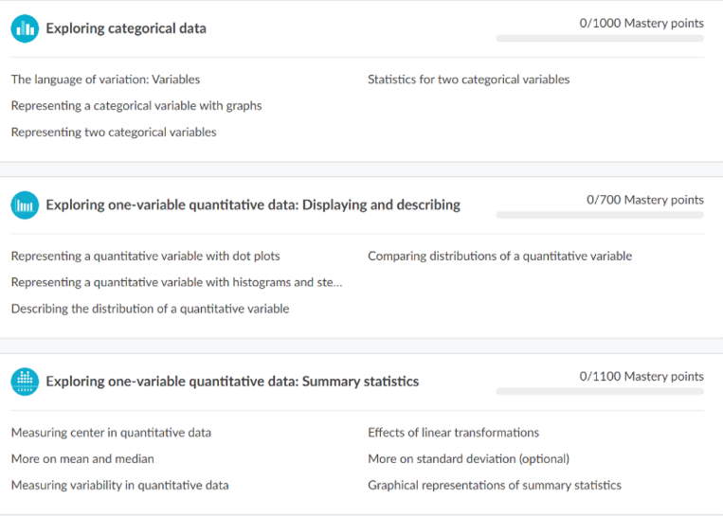

5. When you are complete with the work, you can go under your name and click Learner home. You should see your courses and hopefully an overview of your completion. Please take a screenshot of your completion in AP Statistics and e-mail it to the appropriate teacher. Make sure your name and proof of completion (95% or more) is in your screenshot.

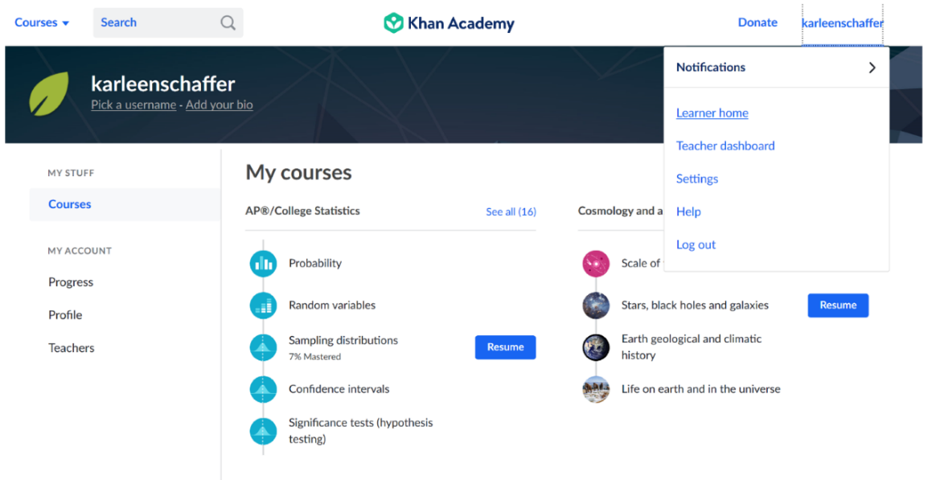

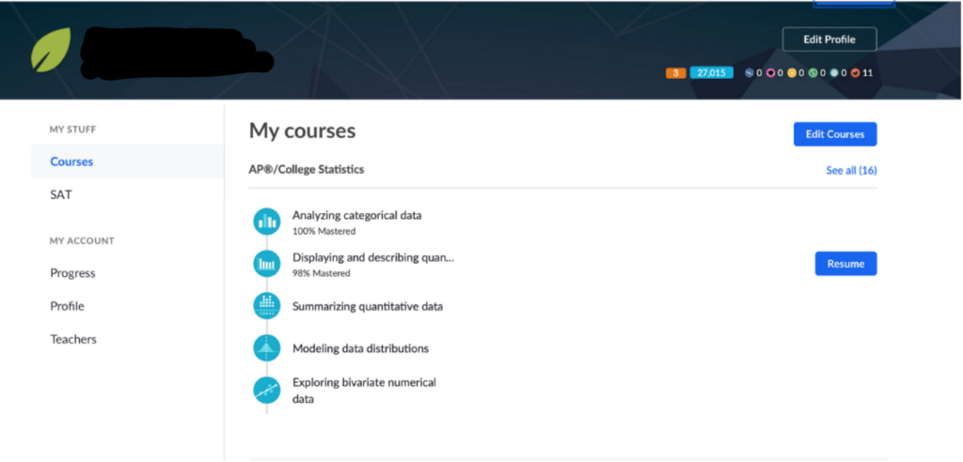
Khan Academy is a great resource that you can continue to use throughout the year. We are glad we could show you how it works so early in the course.

We are very excited to see you and to talk about such important concepts! Enjoy the remainder of the summertime. Please reach out if you have questions!

Mrs. Schaffer and Mr. Mailloux

