[Elements of Fiction](https://nam10.safelinks.protection.outlook.com/?url=https%3A%2F%2Fquizlet.com%2F_7b4n86&data=05%7C01%7C%7C05f708125f9b49b8a18e08da380cfa2d%7Cfa498bc084044719b45244a5a15cbe53%7C0%7C0%7C637883925636647070%7CUnknown%7CTWFpbGZsb3d8eyJWIjoiMC4wLjAwMDAiLCJQIjoiV2luMzIiLCJBTiI6Ik1haWwiLCJXVCI6Mn0%3D%7C3000%7C%7C%7C&sdata=TT2VVY1NXkuMZav3Qg%2BZZJH0A%2FHI9jSfXM4ijU1hhMQ%3D&reserved=0)

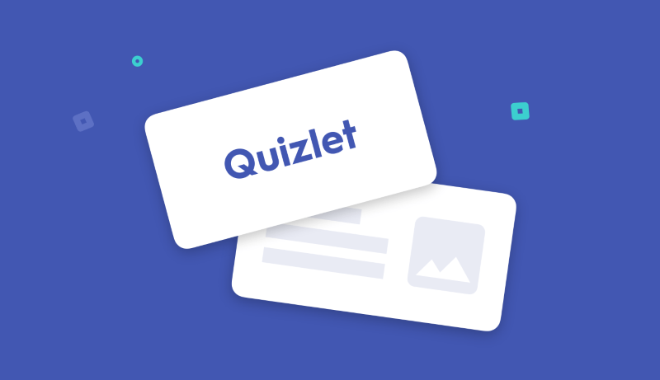

**Style** - the author's word choice, use of language, sentence structure, and tone all contribute to the style of a piece of writing.  One might describe the style of a story as formal, conversational, emotional, unconventional, intimate, humorous, sarcastic, choppy, fluid, poetic, inventive, traditional, ornate . . .

**Point of View** - the vantage point from which a story is told.

***1st person*** uses I/We and tends to be more intimate and immediate.  *After ten long years working in the mill, I finally left Steubenville to try my luck in Las Vegas.*

***2nd person*** uses You addresses the reader directly.  You can't imagine how agonizing life in Steubenville was, but you would also want to try your luck in Las Vegas.

***3rd person*** is the most common point of view used in fiction writing and it's the traditional form in academic writing.  Third person uses he/she/it/they.  ***Third Person Omniscient*** gives the reader a bird's eye view on the action (HE/SHE/THEY).  We have access to 2 or more characters thoughts, feelings and emotions. Often referred to as "god-like" narration style. In a ***Third Person Limited*** the story is told with a limited perspective.  You know more about the experience of a main character and a few close to him or her than you do about the whole situation.  The **third**-**person objective** mode employs a narrator who tells a story without describing any character's thoughts, opinions, or feelings; instead, it gives an **objective**, unbiased point of view. Often the narrator is self-dehumanized in order to make the narrative more neutral.

**Conflict** - a clash of opposing forces in a story. This can be a clash between two characters, two ideas, two emotions, a character and an object, a character and an idea, a character and him or herself . . . A conflict creates tension and keeps the reader invested and engaged.

**Theme** - When thinking about the theme in a novel, play, short story, or poem, I like to consider what important questions or big ideas the author hopes his/her reader confronts while reading the story.

**Symbol** - an object that has a literal meaning but also represents a larger idea.  For example, Odysseus and Penelope's bed is certainly a bed, a soft place to sleep.  However, it has symbolic value because it represent their deeply rooted commitment and steady love.

**Setting** - the time, place, and situation

**Situational Irony** - when there is a contrast between what you would expect and what happens or what is said.  Example: We found it ironic that the head of school asked us to stop doing homework and turn on the TV!  Or, I always am the most prepared person in my family so it was ironic that I was the one who left my passport at home after I'd reminded everyone else a million times.

**Tone** - the mood established in the piece.  A story might be described as having an eerie tone, a sentimental tone, a scornful tone, an optimistic tone . . .

**Figurative Language** - language that is not literal.  Metaphor, simile, hyperbole, understatement

**Characterization**  - all the ways a writer makes a particular character seem real and vivid to the reader.  Characterization occurs through the character's appearance, action, words, interactions and what other characters say about him or her.

**Imagery** - sensory language that helps place the reader there!

**Imagery**: language that evokes the senses - sound, sight, smell, taste, and touch - to place the reader in a setting or an experience.

**Irony:** There are 3 types that I want you to be aware of.

**Verbal irony** is the use of words to mean something different from what a person actually says.

**Dramatic irony** is when the audience is aware of something that the characters in the story are not aware of.

**Situational irony** is when discrepancy between what is expected to happen and what actually happens.

Situation irony occurs when the exact opposite of what is meant to happen, happens.

**Foreshadowing**   earlier hints of what might come later in the story, helps build suspense, keep the reader engaged and curious

**Satire**  poking fun of something with a serious intention  - SNL often satirizes current political issues or politicians themselves

**Allusion** a reference to someone of something from history, art, religion, music or literature